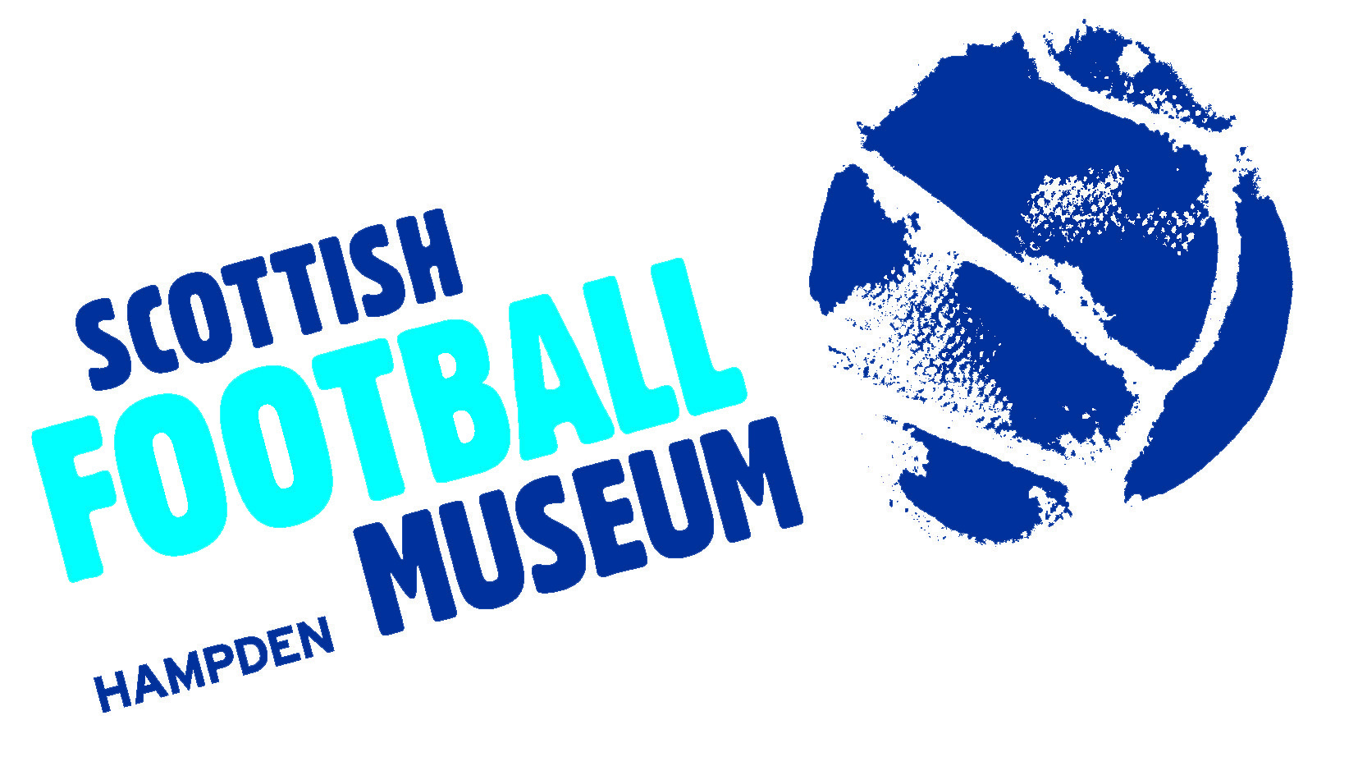

Collections Development Policy

Name of Museum: The Scottish Football Museum

Name of Governing Body: The Scottish Football Association Museum Trust

Approved by the Trustees: 11/12/2019

Date of next review: 11/12/2024

Contents
Relationship to other relevant policies/ plans of the organisation: 3
History of the collections 4
An overview of current collections 4
Themes and priorities for future collecting 5
Themes and priorities for rationalisation and disposal 6
Legal and ethical framework for acquisition and disposal of items 6
Collecting policies of other Museums 6
Archival holdings 6
Acquisition 7
Human remains 7
Biological and geological material 7
Archaeological material 8
Exceptions 8
Spoliation 8
The Repatriation and Restitution of objects and human remains 9
Disposal procedures 9
Disposal by exchange 11
Disposal by destruction 12

Relationship to other relevant policies/ plans of the organisation:
1
  - The Museum’s statement of purpose is:
The Scottish Football Museum exists to promote the unique football heritage of Scotland, to build and maintain a national football collection, to educate and inspire future generations and to support a world class reminiscence.

  - The Collections Development Policy is intended to guide the Curatorial staff and the Board of Trustees of the Scottish Football Museum. The policy relates to the Forward Plan, the Emergency Plan, the Display Policy and the Care and Conservation Policy and Plan.
  - The governing body will ensure that both acquisition and disposal are carried out openly and with transparency.

  - By definition, the Museum has a long-term purpose and holds collections in trust for the benefit of the public in relation to its stated objectives. The governing body therefore accepts the principle that sound curatorial reasons must be established before consideration is given to any acquisition to the collection, or the disposal of any items in the Museum’s collection.

  - Acquisitions outside the current stated policy will only be made in exceptional circumstances.

  - The Museum recognises its responsibility, when acquiring additions to its collections, to ensure that care of collections, documentation arrangements and use of collections will meet the requirements of the Museum Accreditation Standard. This includes using Spectrum primary procedures for collections management. It will take into account limitations on collecting imposed by such factors as staffing, storage and care of collection arrangements.

  - The Museum will undertake due diligence and make every effort not to acquire, whether by purchase, gift, bequest or exchange, any object or specimen unless the governing body or responsible officer is satisfied that the Museum can acquire a valid title to the item in question.

  - The Museum will not undertake disposal motivated principally by financial reasons.
2

History of the collections
The Scottish Football Association Museum Trust was officially constituted in 1994 as a result of a partnership between the Scottish Football Association and Glasgow City Council. The Scottish FA donated its own collection to the new Museum and Queen’s Park Football Club, Scotland’s first Association football club, loaned its collection. The first exhibition of the new Museum opened in June 1994 at Glasgow’s Museum of Transport and was a launch pad to commence work building up a general collection which comprised of public donations and donations from football related organisations as well as items bought at auction or through private sale.
In May 2001, the Museum officially opened its doors at Hampden Park. The Museum developed close links with other football organisations such as the Scottish Amateur FA and the Scottish Junior FA and added these historic collections under loan agreement. By 2008 as the Museum underwent accreditation with Museums Libraries Archives, the following collections came under the care of the Museum; The Scottish FA Collection, The Queen’s Park FC Collection, The General Collection, The Scottish Football League Collection, The Scottish Junior FA Collection, The Scottish Amateur FA Collection, The Glasgow Schools FA Collection and The Hampden Park Collection.
The collections of the Museum were awarded Recognised Status in 2009 and the Museum has since added the collection of Scottish Women’s Football. In 2013 the merger of the Scottish Football League and Scottish Premier League into the Scottish Professional Football League has meant that a much enlarged collection has been offered to the Museum.

An overview of current collections
3
The central area of interest within the collections of the Museum concerns the history of Association football in Scotland, dating from 1867 to the present day. Within this context our collections reflect football at local, national and international level.
The Museum’s core collections include the Queen’s Park FC collection (the first Association football club in Scotland and owners of Hampden Park) and the Scottish FA collection (the governing body for Association football in Scotland since 1873. We also have collections representing the affiliated Associations which take in youth football, schools football, amateur football, women’s football and junior football. Scotland’s senior football clubs and the Scottish Professional Football League are represented within our collections.
Beyond this central area of interest, the topic relating to the origins of Scottish football (i.e. pre-1867) is also regarded as an important collecting area and we have a small collection reflecting this particular field. As a social history Museum our collections provide a link between football and important social and cultural developments in late 19th and 20th century Scotland. In particular themes linking football in Scotland to the economic depression of the 1930s, the two world wars, the struggle for women’s rights within Scottish society, media and commercialism, fan culture, stadium architecture, the dissemination of football, Irish immigration in the 19th century and the Scottish Diaspora are represented within our collections.

Themes and priorities for future collecting
4
The Museum will continue to develop an acquisitions policy which will reflect the heritage of Scottish football at local, national and international level. Objects and ephemera relating to the history of Association football in Scotland from 1867 to the present day will be considered. Although not an exhaustive list, we will, in particular, consider the following themes as being pertinent to our acquisition policy; the Scotland national football teams, Scotland’s senior clubs, Scottish junior football, Scottish amateur football, women’s football in Scotland, youth football in Scotland, Scottish football origins, football and the media, football and social history, football and commercialism, fan culture, football games and hobbies, stadium architecture in Scotland, football and the Scottish Diaspora. Although all areas of the Museum’s collection remain open to future acquisition, the Museum will review this position within the framework of future reviews of the acquisitions policy.
For each area of interest we will satisfy the following criteria before allowing objects to be brought into the collection:
1) Is the item consistent with the acquisitions policy?
2) Is the physical condition of the object acceptable? If not, does the Museum have available resources to bring the object up to display standard?
3) Will the acquisition fill a gap in the collection?
4) Does the object complement or supplement existing material?
5) In relation to objects offered on a loan basis - Will the Museum display / use the object within three years? If not the loan should be refused.
6) Will the Museum have total control over reproduction rights to the object? If not, are the conditions acceptable to the Museum?
7) Is the provenance of the object certain?
8) Is the ownership of the object certain?

Themes and priorities for rationalisation and disposal
5
5.1 The Museum does not intend to dispose of collections during the period covered by this policy. During the period of this policy, disposal is not a priority unless for legal, safety or care and conservation reasons (for example, spoliation, radiation, infestation, repatriation).

Legal and ethical framework for acquisition and disposal of items
6
6.1 The Museum recognises its responsibility to work within the parameters of the Museum Association Code of Ethics when considering acquisition and disposal.

Collecting policies of other Museums
7
  - The Museum will take account of the collecting policies of other Museums and other organisations collecting in the same or related areas or subject fields. It will consult with these organisations where conflicts of interest may arise or to define areas of specialism, in order to avoid unnecessary duplication and waste of resources.

  - Specific reference is made to the following Museum(s)/organisation(s):

National Football Museum, Manchester United FC Museum, Liverpool FC Museum, Arsenal FC Museum, West Ham United FC Museum, Manchester City FC Museum, Heart of Midlothian FC Museum

Archival holdings
8
The Museum holds a substantial archive which consists of the SFA collection, the Queen’s Park collection, the SPFL collection as well as individual donations and loans. The SFA collection is a formal donation to the Museum and consists of SFA minutes from the 19th Century onwards, programmes, letter correspondence, photographs and newspaper articles. The Queen’s Park collection is a long-term loan to the Museum and holds material such as scrapbooks, photographs and letter correspondence. The SPFL collection was previously a long-term loan and is in the process of becoming a formal donation. The SPFL collection forms a significantly large part of the archive and holds material such as player contracts, letter correspondence and meeting minutes. In addition to this we have a small archive which consists of individual loans and donations and includes material such as programmes, photographs, post cards and illustrations.

Acquisition
9
  - The policy for agreeing acquisitions is:
The Museum will exercise due diligence and make every effort not to acquire, whether by purchase, gift, bequest or exchange, any object or specimen unless the governing body or responsible officer is satisfied that the Museum can acquire a valid title to the item in question.
  - The Museum will not acquire any object or specimen unless it is satisfied that the object or specimen has not been acquired in, or exported from, its country of origin (or any intermediate country in which it may have been legally owned) in violation of that country’s laws. (For the purposes of this paragraph ‘country of origin’ includes the United Kingdom).

  - In accordance with the provisions of the UNESCO 1970 Convention on the Means of Prohibiting and Preventing the Illicit Import, Export and Transfer of Ownership of Cultural Property, which the UK ratified with effect from November 1 2002, the Museum will reject any items that have been illicitly traded. The governing body will be guided by the national guidance on the responsible acquisition of cultural property issued by the Department for Culture, Media and Sport in 2005.

Human remains
10
10.1 The Museum does not hold or intend to acquire any human remains.

Biological and geological material
11
11.1 So far as biological and geological material is concerned, the Museum will not acquire by any direct or indirect means any specimen that has been collected, sold or otherwise transferred in contravention of any national or international wildlife protection or natural history conservation law or treaty of the United Kingdom or any other country, except with the express consent of an appropriate outside authority.

Archaeological material
12
  - The Museum will not acquire archaeological material (including excavated ceramics) in any case where the governing body or responsible officer has any suspicion that the circumstances of their recovery involved a failure to follow the appropriate legal procedures.
12.2 In Scotland, under the laws of bona vacantia including Treasure Trove, the Crown has title to all ownerless objects including antiquities, although such material as human remains and environmental samples are not covered by the law of bona vacantia. Scottish material of chance finds and excavation assemblages are offered to Museums through the treasure trove process and cannot therefore be legally acquired by means other than by allocation to Scottish Football Museum by the Crown. However where the Crown has chosen to forego its title to a portable antiquity or excavation assemblage, a Curator or other responsible person acting on behalf of the Scottish Football Association Museum Trust, can establish that valid title to the item in question has been acquired by ensuring that a certificate of ‘No Claim’ has been issued on behalf of the Crown.

Exceptions
13
  - Any exceptions to the above clauses will only be because the Museum is:
    - acting as an externally approved repository of last resort for material of local (UK) origin
    - acting with the permission of authorities with the requisite jurisdiction in the country of origin
In these cases the Museum will be open and transparent in the way it makes decisions and will act only with the express consent of an appropriate outside authority. The Museum will document when these exceptions occur.

Spoliation
14

14.1 The Museum will use the statement of principles ‘Spoliation of Works of Art during the Nazi, Holocaust and World War II period’, issued for non-national Museums in 1999 by the Museums and Galleries Commission.

The Repatriation and Restitution of objects and human remains
15
  - The Museum’s governing body, acting on the advice of the Museum’s professional staff, if any, may take a decision to return human remains (unless covered by the ‘Guidance for the Care of Human Remains in Scottish Museums’ issued by MGS in 2011), objects or specimens to a country or people of origin. The Museum will take such decisions on a case by case basis; within its legal position and taking into account all ethical implications and available guidance. This will mean that the procedures described in 16.1-5 will be followed but the remaining procedures are not appropriate.

  - The disposal of human remains from Museums in Scotland will follow the guidelines in the ‘Guidance for the Care of Human Remains in Scottish Museums’ issued by Museums
Galleries Scotland in 2011.

Disposal procedures
16
  - All disposals will be undertaken with reference to the Spectrum primary procedures on disposal.

  - The governing body will confirm that it is legally free to dispose of an item. Agreements on disposal made with donors will also be taken into account.

  - When disposal of a Museum object is being considered, the Museum will establish if it was acquired with the aid of an external funding organisation. In such cases, any conditions attached to the original grant will be followed. This may include repayment of the original grant and a proportion of the proceeds if the item is disposed of by sale.

  - When disposal is motivated by curatorial reasons the procedures outlined below will be followed and the method of disposal may be by gift, sale, exchange or as a last resort – destruction.

  - The decision to dispose of material from the collections will be taken by the governing body only after full consideration of the reasons for disposal. Other factors including public benefit, the implications for the Museum’s collections and collections held by Museums and other organisations collecting the same material or in related fields will be considered. Expert advice will be obtained and the views of stakeholders such as donors, researchers, local and source communities and others served by the Museum will also be sought.

  - A decision to dispose of a specimen or object, whether by gift, exchange, sale or destruction (in the case of an item too badly damaged or deteriorated to be of any use for the purposes of the collections or for reasons of health and safety), will be the responsibility of the governing body of the Museum acting on the advice of professional curatorial staff, if any, and not of the curator or manager of the collection acting alone.
  - Once a decision to dispose of material in the collection has been taken, priority will be given to retaining it within the public domain. It will therefore be offered in the first instance, by gift or sale, directly to other Accredited Museums likely to be interested in its acquisition.

  - If the material is not acquired by any Accredited Museum to which it was offered as a gift or for sale, then the Museum community at large will be advised of the intention to dispose of the material normally through a notice on the MA’s Find an Object web listing service, an announcement in the Museums Association’s Museums Journal or in other specialist publications and websites (if appropriate).

  - The announcement relating to gift or sale will indicate the number and nature of specimens or objects involved, and the basis on which the material will be transferred to another institution. Preference will be given to expressions of interest
from other Accredited Museums. A period of at least two months will be allowed for an interest in acquiring the material to be expressed. At the end of this period, if no expressions of interest have been received, the Museum may consider disposing of the material to other interested individuals and organisations giving priority to organisations in the public domain.

  - Any monies received by the Museum governing body from the disposal of items will be applied solely and directly for the benefit of the collections. This normally means the purchase of further acquisitions. In exceptional cases, improvements relating to the care of collections in order to meet or exceed Accreditation requirements relating to the risk of damage to and deterioration of the collections may be justifiable. Any monies received in compensation for the damage, loss or destruction of items will be applied in the same way. Advice on those cases where the monies are intended to be used for the care of collections will be sought from Museums Galleries Scotland.
  - The proceeds of a sale will be allocated so it can be demonstrated that they are spent in a manner compatible with the requirements of the Accreditation standard. Money must be restricted to the long-term sustainability, use and development of the collection.

  - Full records will be kept of all decisions on disposals and the items involved and proper arrangements made for the preservation and/or transfer, as appropriate, of the documentation relating to the items concerned, including
photographic records where practicable in accordance with
Spectrum procedure on deaccession and disposal.

Disposal by exchange
  - The nature of disposal by exchange means that the Museum will not necessarily be in a position to exchange the material with another Accredited Museum. The governing body will therefore ensure that issues relating to accountability and impartiality are carefully considered to avoid undue influence on its decision-making process.
    - In cases where the governing body wishes for sound curatorial reasons to exchange material directly with Accredited or non-Accredited Museums, with other organisations or with individuals, the procedures in paragraphs 16.1-5 will apply.
    - If the exchange is proposed to be made with a specific Accredited Museum, other Accredited Museums which collect in the same or related areas will be directly notified of the proposal and their comments will be requested. If the exchange is proposed with a non-Accredited Museum, with another type of organisation or with an individual, the Museum will place a notice on the MA’s Find an Object web listing service, or make an announcement in the Museums Association’s Museums Journal or in other specialist publications and websites (if appropriate).
    - Both the notification and announcement must provide information on the number and nature of the specimens or objects involved both in the Museum’s collection and those intended to be acquired in exchange. A period
of at least two months must be allowed for comments to be received. At the end of this period, the governing body must consider the comments before a final decision on the exchange is made.

Disposal by destruction
  - If it is not possible to dispose of an object through transfer or sale, the governing body may decide to destroy it.

  - It is acceptable to destroy material of low intrinsic significance (duplicate mass-produced articles or common specimens which lack significant provenance) where no alternative method of disposal can be found.

  - Destruction is also an acceptable method of disposal in cases where an object is in extremely poor condition, has high associated health and safety risks or is part of an approved destructive testing request identified in an organisation’s research policy.

  - Where necessary, specialist advice will be sought to establish the appropriate method of destruction. Health and safety risk assessments will be carried out by trained staff where required.

  - The destruction of objects should be witnessed by an appropriate member of the Museum workforce. In
circumstances where this is not possible, e.g. the destruction of controlled substances, a police certificate should be obtained and kept in the relevant object history file.

Signed,

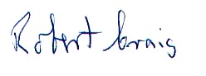

Robert Craig,
Museum Chair

