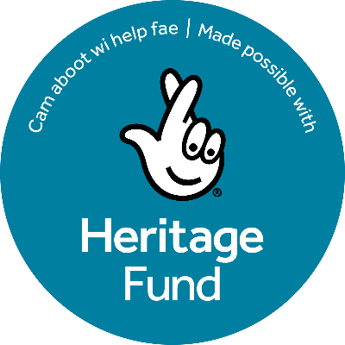

Scottish Football Museum

Local Heritage Grants Application

Completing this form
The following questions allow us to assess your application against our grant criteria.

We strongly recommend you read the grant guidance notes before completing this form.

Please return the completed form to Demi Boyd – demi.boyd@scottishfootballmuseum.org.uk.

If you have any access needs, or require assistance to complete this form, please contact Demi Boyd - demi.boyd@scottishfootballmuseum.org.uk.

How we assess your application
All applications will be assessed by an independent panel consisting of: (need to confirm). You should ensure that your grant application demonstrates how your project will meet our objectives as closely as possible. We assess and score applications alongside the key criteria outlined below:
- How your project celebrates & engages local football heritage
- How your project engages with the community
- The need to do the activity you are seeking funding for
- How well research and developed your project idea is
- The impact that your proposed activity will have
- The deliverability of your project

1. What is the name of your organisation or group?

2. Where is your organisation or group based in Scotland?

3. Do you have a formal constitution? We can only accept applications from formally constituted groups.
Yes
No

4. What is the name of the main contact?

5. Please provide the email address we should use to contact you about your application.

6. Please provide a brief outline of your project idea. Cannot be on a project that has already begun.
Applications for funding can be made for specific one-off projects or for a series of projects that can include photographic displays; online/digital exhibitions; plays, musicals, heritage trails; physical displays and exhibitions; heritage/anniversary matches; conservation of existing resources; digital projects; learning and engagement. However, any project or activity within the broad scope of local football heritage will be considered.
We'd like to know:
- what the football heritage is you'll be working with (is it collection, oral history, archive etc)
- how the heritage ties in to your local community
- what impact your project will have

7. Tell us who will deliver your project and who your project will engage / involve

8. Why do you want to do this project?

9. Is your project a partnership? Please provide details of all parties involved in delivering the project.

10. Let us know how much funding you are requesting from the Scottish Football Museum Community Heritage Grants Fund in support of this project. For projects costing more than £1,500, do you have access to the additional amount? (Maximum £1,500. No requirement for match funding).

11. Please provide a brief outline of project costs.
Please be clear which costs are being requested from this grant if you are also using other funding to deliver your project. If you are unsure if your project costs are eligible for this fund, please contact Demi Boyd - demi.boyd@scottishfootballmuseum.org.uk.
Examples of what the Local Heritage Grants can support:
- Creating resources
- Delivering events
- Arranging transport to deliver the project or activity
- Marketing and publicity
- Volunteer expenses (non-payroll & core to delivering the project or activity)
- Purchasing equipment
- Engaging consultants / experts
- Delivering temporary exhibitions

12. Please confirm that if you are successful in securing a grant, you will be able to abide by the conditions of the grant, outlined in our guidance notes.
Yes
No

