

**A Highlights Guide**

**A Highlights Guide**

This booklet will help you to make the most of your visit to us. Feel free to take photos at any point, and don’t forget to tag us **@SFootballMuseum** on Facebook,

Twitter or Instagram!





**Museum Map**

**The Scottish Football Hall of Fame**

**The Hampden Roar, 1903-45**

**The Early Years, 1867-1902**

**Changing Times, 1946-79**

**START**



**GameZone**

**Clubs Gallery**

**Scots Away**

**SFA International Roll of Honour**

**A New Era: 1980-Now**

**The Old Dressing Room**

**Temporary Exhibition Area**

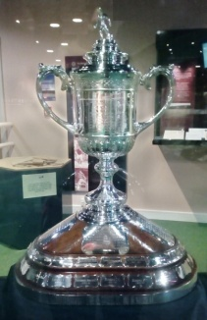

**The Early Years: 1867- 1902**

Glasgow has a lot to boast about: the oldest Association football club in Scotland was founded here (Queens Park, founded in 1867), the world’s first international match under Association rules was played here (Scotland vs. England, played in Partick in 1872), and Hampden is home to the oldest national football trophy in the world (the Scottish Cup, made in 1874). You can find out more about all of these things in this gallery, and also see the original Scottish Cup in all its glory.

**Don’t miss:** the Queens Park Chain of Office, made from 93 gold medals joined together, which is still used by the club on ceremonial occasions.

**Discussion point: Is there anything that interests or surprises you in this gallery? If so, why?**

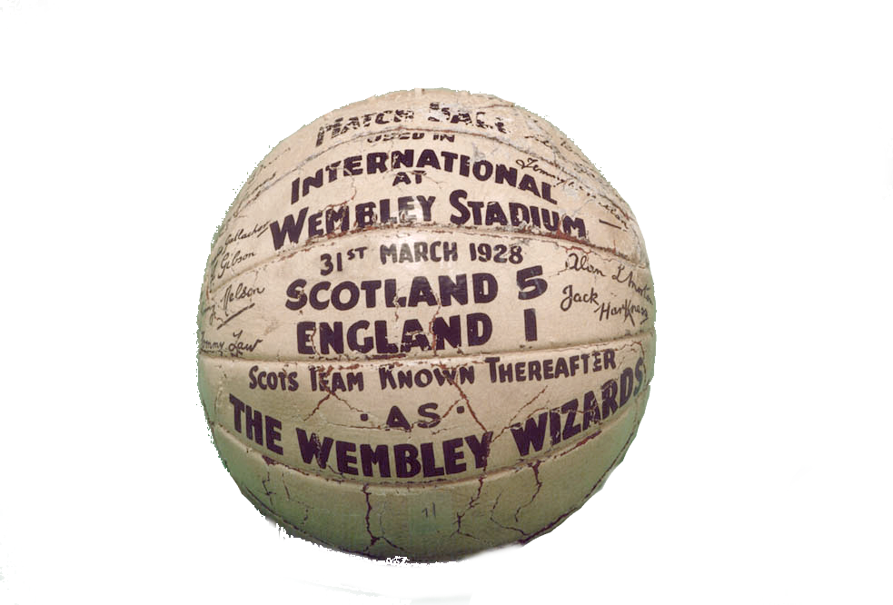

**The Hampden Roar: 1903- 1945**

This was a difficult time for Scottish football, with many players injured and killed on the battlefield during two World Wars. Women’s football was hit with a ban in 1921, after the football establishment decided that playing football was ‘unladylike’ and bad for revenue. The ban stayed in place for over 50 years. However, one silver lining from this period is Scotland’s 5-1 victory over England in 1928, which saw the team nicknamed ‘The Wembley Wizards’.

**Look out for:** the Wembley Wizards ball, which goalkeeper Jack Harkness stuffed under his jersey when leaving the field after this impressive victory. It’s signed by the entire Scotland squad.

**Discussion point: How do you think that opportunities for women and girls to get involved in football have improved?**

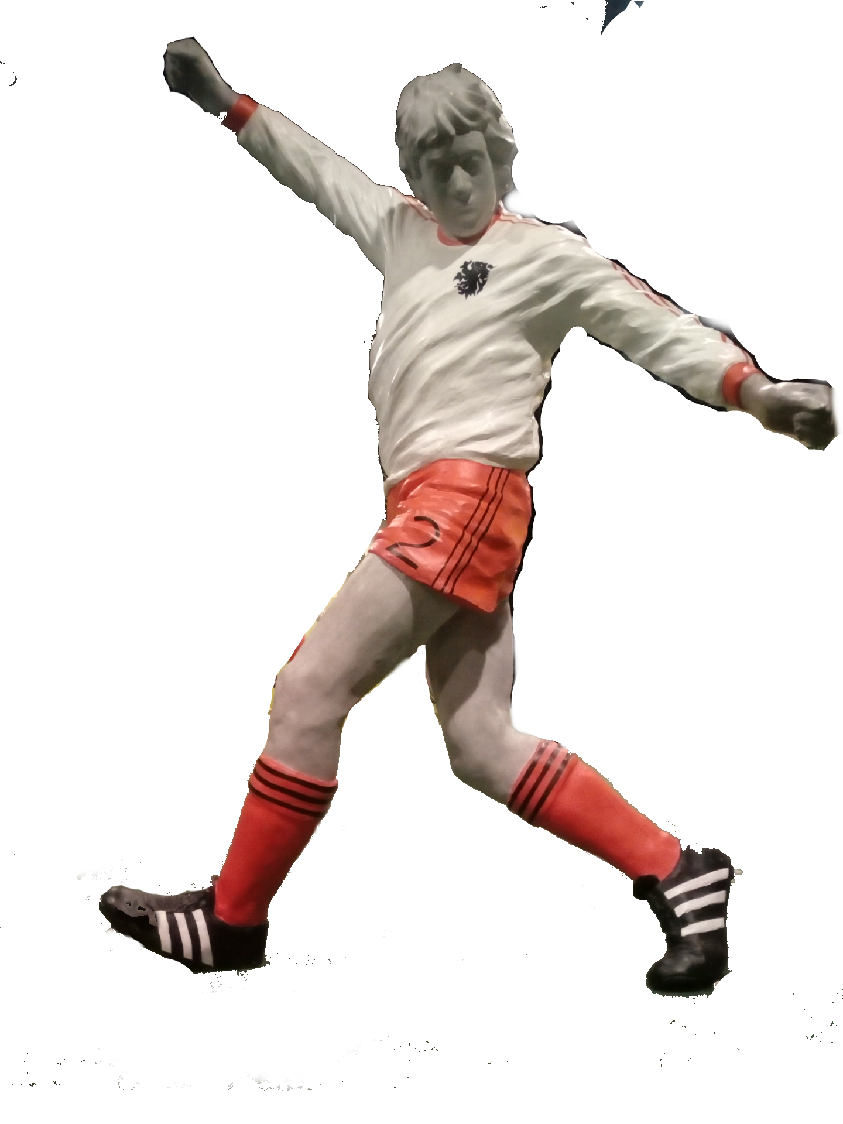

**Changing Times: 1946 - 1979**

This period saw a golden age of club football, with Celtic winning the European Cup in Lisbon in 1967, and Rangers beating Dynamo Moscow to lift the European Cup Winners’ Cup in 1972. The national team did not do as well, seen in their disappointing performance at the 1978 FIFA World Cup. However, Archie Gemmill scored an amazing goal against the Netherlands during that tournament, which is still ranked as one of the best-ever World Cup goals.

**Highlights:** here you can watch footage of that amazing goal in ’78, and also see an original programme from Celtic’s greatest ever victory.

**Discussion point: Why do you think people enjoy watching and playing football? Do you think the history of football tells us anything about its fans?**

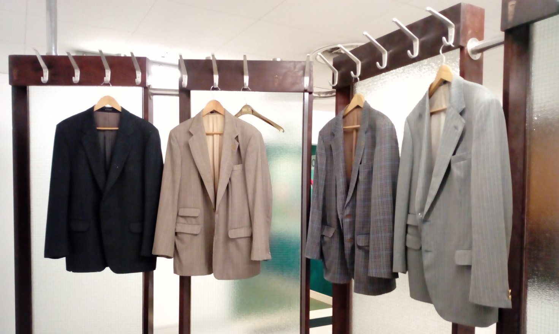

**The Old Dressing Room**

Here you can get a sense of how the dressing rooms used to look before the stadium was redeveloped in the 1990s. The dressing room was painstakingly removed and reinstalled in the museum space, and the only thing missing is the communal bath, which was too heavy to be installed on this floor.

**Don’t miss: T**his room is ordinarily fitted with an atomiser to give you an idea of how dressing rooms used to smell. Can you smell the aroma of the embrocation used to relieve muscle strains?

**Discussion point: How does this room compare to the stadium’s new dressing rooms? How about those at your school/college?**

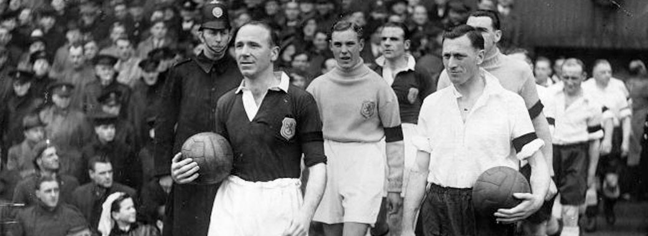

**Temporary Exhibition Gallery**

This part of the museum is home to our temporary exhibitions. Check on our website to see what is on when you visit, which could be anything from a history of shinty to football and mining.

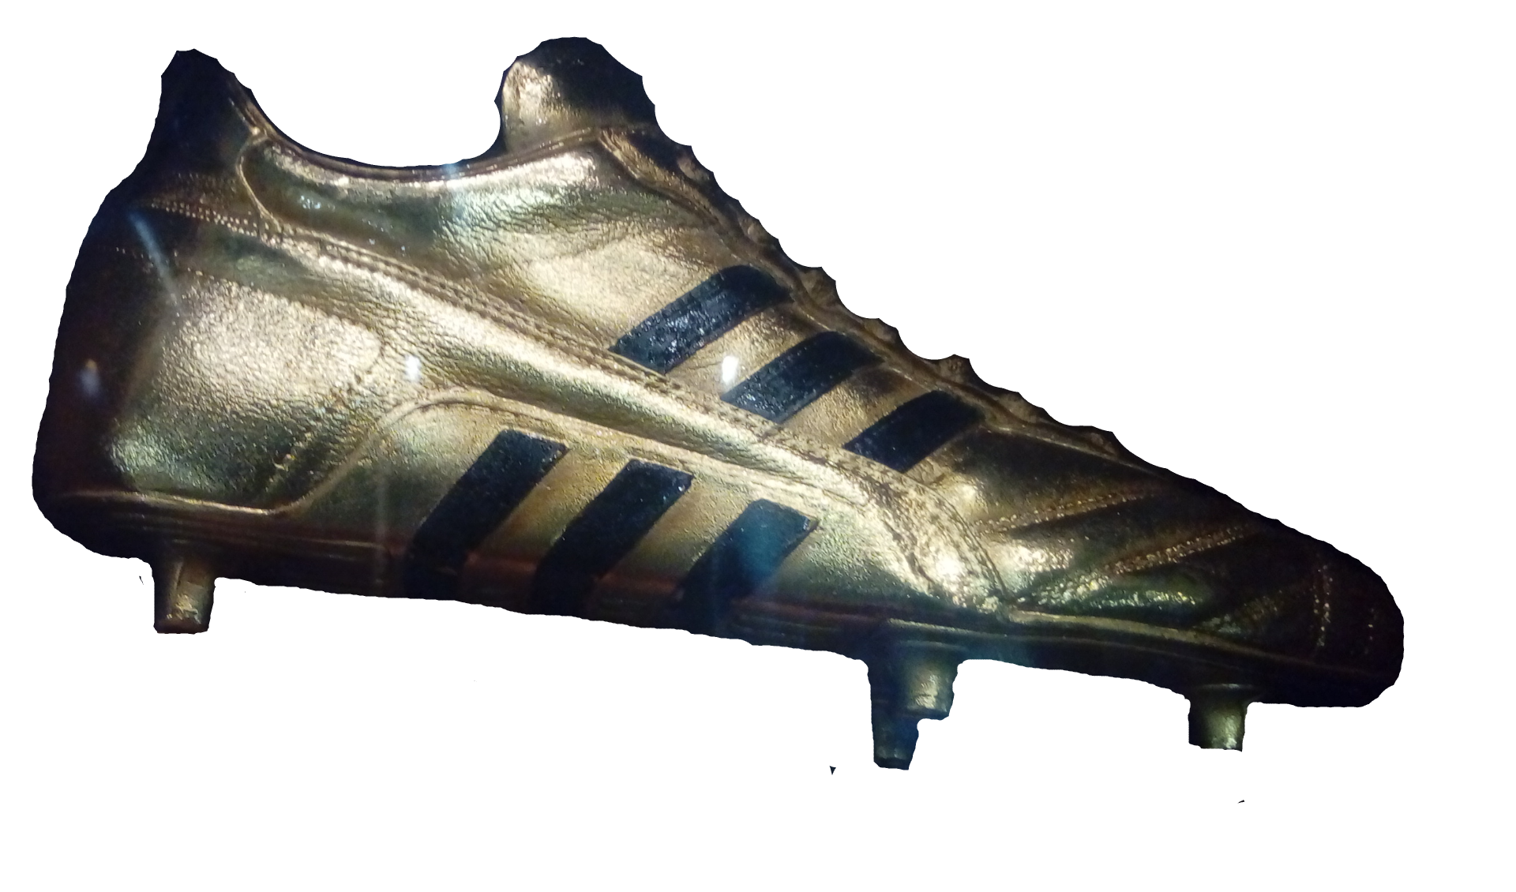

**A New Era: 1980 - Now**

The women’s team has gone from strength to strength in recent years, qualifying for both UEFA EURO 2017 and the 2019 FIFA World Cup. In both tournaments they narrowly missed out on a place in the elimination rounds. There have been big changes in the men’s game too, with the rise to iconic status of players, largely due to media attention and high profile tournaments, which really took off after 1980.

**Look out for:** Ally McCoist’s Golden Boot, one of two he received, in consecutive season’s, as the top goalscorer in a European league season whilst with Rangers.

**Discussion point: How do you feel about the high salaries that football players receive these days?**

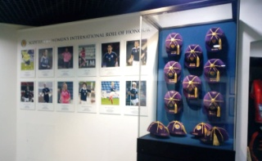

**SFA International Roll of Honour**

Here players, both men and women, who have played at least 50 times for their country are commemorated.

**Don’t miss:** our Hampden Moments video in the centre of the space, showing some of the highlights from the stadium’s history.

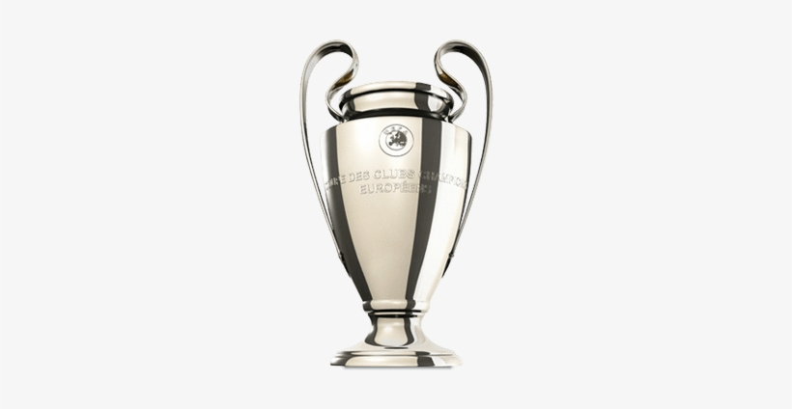

**The Clubs Gallery**

This gallery contains a jersey for each of the 42 senior men’s teams in Scotland.

**Scots Away**

The Champions League Trophy is hard to miss here. It is the replica presented to Sir Alex Ferguson when Manchester United won the title in Barcelona in 1999.

**Look out for:** the archive room, where 150 years of football history are stored.

**Discussion point: Think about the mix of original objects and replicas in this space. What do you think of replica items in museums?**

**The Hall of Fame**

This gallery honours those who have made a significant contribution to Scottish football, both on and off the pitch. Each year inductees are chosen from a short list compiled from nominations made by the public, by an independent judging panel, before being officially inducted at an annual awards ceremony at Hampden Park. There are now over 120 inductees.

**Highlights:** see if you can find the latest inductees into the Hall of Fame. You can also nominate someone yourself using the nominations box in one corner of this gallery. If you want to do this, bear in mind that if you choose a player, they will require to have retired from their playing career.

**Discussion point: Apart from players, what other categories of people are commemorated here?**

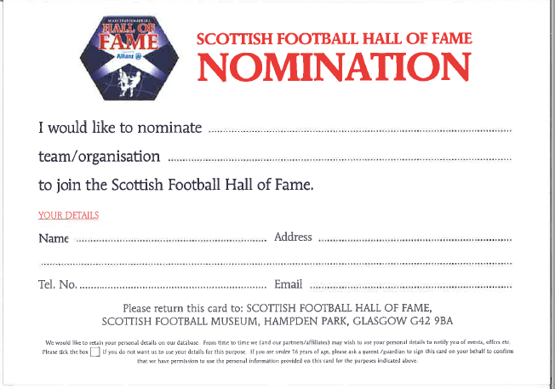

**That’s the end of the tour. Before you go, don’t forget to visit our Gamezone where you can challenge your friends to the latest version of FIFA™!**



Copyright © Scottish Football Museum 2020. Not for commercial use.