**Scottish Football Museum Teachers’ Booklet**

These notes have been designed to allow teachers to conduct independent tours of the museum. Each main section of the museum is covered by notes and a series of activities, which can be photocopied for ease of use within the museum. The activities in the booklet have been designed for children under the age of 12: the Activity Sheets are slightly easier and designed for children under 8, and the Quizzes are written with children aged 9-12 in mind. For teenagers and older groups, please refer to the Museum Highlights Tour, which contains information for a self-guided tour and topics for discussion. Alongside these sheets, you can also find more resources in the museum itself, including quizzes and an activity trail for temporary exhibitions. For more information about these, email [info@scottishfootballmuseum.org.uk](mailto:info@scottishfootballmuseum.org.uk) or speak to staff at the Research Desk during your visit.

**Contents**

**3 Museum Map**

**4 The Early Years, 1867- 1902**

**7 The Hampden Roar, 1903-1945**

**11 Changing Times, 1946-1979**

**15 A New Era, 1980- Present Day**

**18 The Scottish Football Hall of Fame**

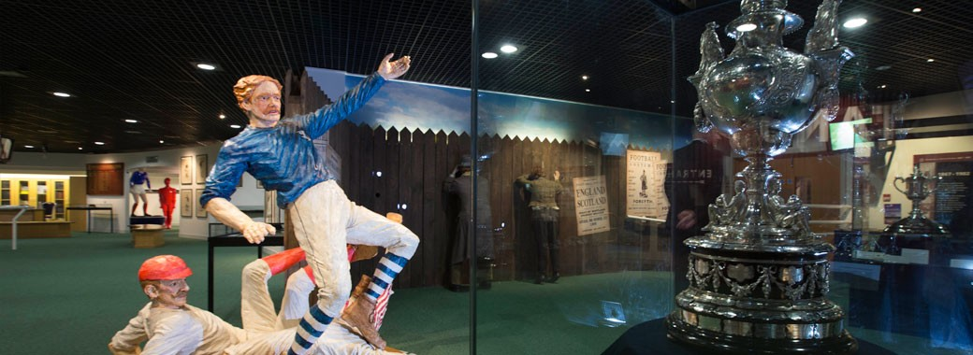

**Learning Outcomes**

A visit to the Scottish Football Museum is an excellent way to build on the strength of the Curriculum for Excellence’s Four Capacities, as outlined below:

* **Successful Learners**

Pupils will be given the chance to learn about subjects from a different angle, taking ideas learned in the classroom into a new context. This will allow them to think more imaginatively about topics covered in school.

* **Confident Individuals**

A visit to the Scottish Football Museum will allow pupils to learn more about the history of Scotland, giving pupils a greater understanding of local history and cultural heritage. Through being encouraged to ask questions, pupils will feel more confident in expressing themselves in group settings.

* **Responsible Citizens**

Our museum will help pupils gain a greater understanding of the world of sport, together with Scotland’s role within it. With Scotland being a pioneer of Association Football, there is a lot to be proud of and a wealth of heritage which needs to be preserved for future generations. It is hoped that by introducing pupils to the importance of our collection, they will better understand the need to take care of it in the future.

* **Effective Contributors**

Throughout the museum space and the stadium tour, pupils will be encouraged to ask questions and reflect on what they have seen. In this way, they will become much more fluent when communicating their thoughts. It will also allow them to develop better critical thinking skills, in order to analyse knowledge learned from a broad range of sources.

In addition to the Four Capacities, a visit to our museum ties in with the **Social Studies** area of the curriculum. After a visit to us, pupils will be better able to:

* Develop an understanding of the history, heritage and culture of Scotland, and an appreciation of their local and national heritage within the world
* Broaden their understanding of the world by learning about human activities and achievements in the past and present
* Learn how to locate, explore and link periods, people and events in time and place, locally and further afield

**Museum Map**

**The Scottish Football Hall of Fame**

**The Hampden Roar, 1903-45**

**Changing Times, 1946-79**

**The Early Years, 1867-1902**



**GameZone**

**Clubs Gallery**

**SFA International Roll of Honour**

**A New Era:**

**1980-Now**

**The Old Dressing Room**

**Special Exhibition Area**

**As you can see, once you have completed the resources in this book there is plenty more to enjoy! Visit the Old Dressing Room to see where the players used to get changed. Can you smell the aroma of the embrocation used to relieve muscle strains? Then check out our Special Exhibition Area to see what exciting displays we have on at present. Finally, finish off your visit with a trip to the GameZone, where your students can go head to head on the latest version of FIFA!**

**The Early Years, 1867-1902**

Key Topics

Hampden Park was built to house the oldest Association football club in Scotland, **Queen’s Park**, who were founded in 1867. Their home ground has moved a few times but have been on this site since 1903. Queen’s Park were an influential team in the early days and played as Scotland in the w**orld’s first international** football match under Association Rules in 1872, which took place at the West of Scotland cricket grounds in the west of Glasgow. Not to be outdone, the first women’s football match under Association Rules took place less than 10 years later in 1881, this time in Edinburgh. Scotland really was there at the beginning of the modern game.

An important player from Scotland’s early Association football days was Queen’s Park’s **RS McColl.**  He scored 13 goals for Scotland, and when he made the decision to turn professional was invited to play in England by several clubs. He played three seasons there for Newcastle United before returning to Scotland to play for Rangers. When he retired from football he went into partnership with his brother and opened a sweet shop, and this is where the name of the retailer McColl’s comes from.

Another key player is **Andrew Watson**, who you can see in the video display in this part of the museum. Watson was the first person of colour in the world to play international football, and he also played with Queen’s Park, captaining Scotland for their 6-1 defeat of England in 1881.

**The Scottish Cup** was made in 1874 and is the oldest national football trophy in the world. It is made from solid silver and displays the names of every team which has won the competition since its foundation. After Celtic and Rangers, Queen’s Park have won the trophy more times than any other club, though they haven’t won it for a very long time.

*Key objects*

*From left to right: a ticket from the first men’s international, 1872; The Scottish Cup; Painting of Lily St. Clare, a pioneer of women’s football; RS McColl’s Scotland jersey; the Queen’s Park Chain of Office.*

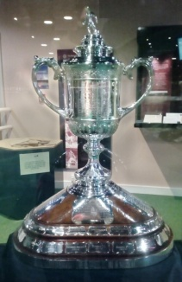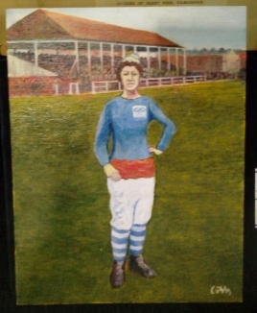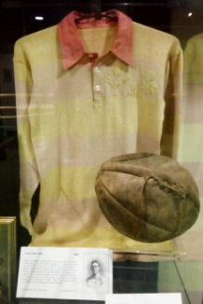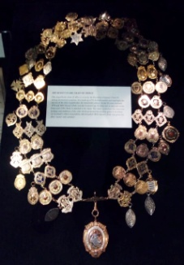

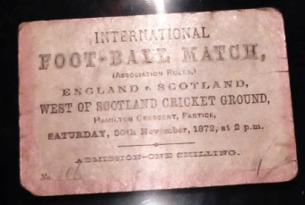

Activity Sheet on page 5 - Answers

Quiz on page 6 - Answers

1. –
2. A pig’s bladder
3. Scored a goal
4. Any of the following: Liverpool, Derby County, Blackburn Rovers, Aston Villa
5. -
6. One shilling
7. 93
8. Queens Park
9. 1874
10. Pink and yellow/ the Rosebery colours
11. 1876
12. 1900
13. Two fish (though the eagle-eyed may

also spot a human being and a bird!)

The Early Years Activity Sheet

The Early Years Quiz

1. Has your team ever won the Scottish Cup? If so, how many times have they won? Try to find their name on the base of the trophy.

.............................................................................................................

1. What was inside an old leather football to make it inflate? (Hint: it’s a bit gross!)

..............................................................................................................

1. Find the painting of Lily St Clare in one of the display cases. What did she do before anyone else?

...............................................................................................................

1. Can you name one of the teams that tried to persuade RS McColl to play for them?

...............................................................................................................

1. Imagine you were at the first international match in 1872. Maybe you have never seen a football match before, so you don’t even know the rules. Maybe you have been waiting for hours in the queue to get in and you can’t feel your toes anymore! Can you think of 5 words to describe how you might feel? We have added to couple to start you off.

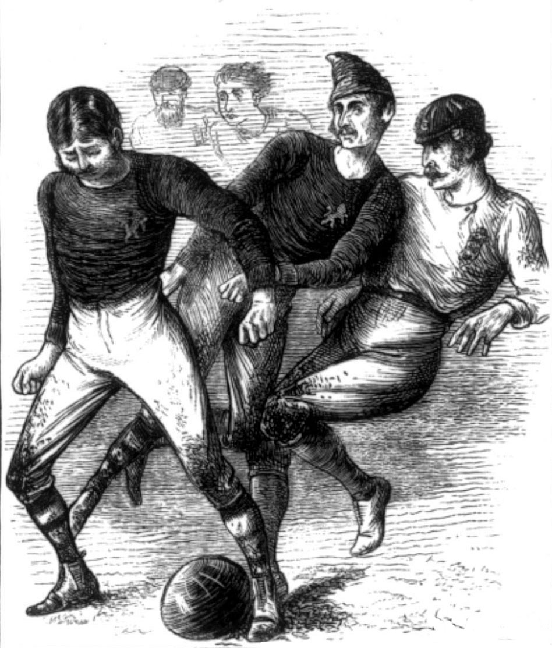

Excited

Confused

...............................

...............................

...............................

..............................

..............................

**The Hampden Roar, 1903-45**

Key Topics

This period saw **two world wars** drastically affect the Scottish game. During WWI League football continued as a way to keep up morale, but this was frowned upon by others who said that players should set a good example. However, many professional players did enlist, which lead others to argue that football was good for recruitment. During WWII, no official games took place. However, this didn’t stop some from playing, including **Tommy Walker** who started a team with his fellow soldiers while stationed in India.

The women’s game saw dramatic changes during this time, with 1921 seeing a flat **ban on women playing** at Association grounds. This didn’t stop women playing but it did make it a lot harder, with players having to change on the pitch and sneak into grounds on Sundays when nobody was using them.

In 1928, Scotland secured a historic 5-1 victory over England at Wembley stadium. The team got the nickname the **Wembley Wizards** as nobody had been expecting them to win that day! At this time, stadiums had very few seats, so people stood to watch games. This meant that you could fit a lot more people into the stadium, and Hampden used to hold a World Record attendance figure: 149 415 people watched Scotland play England in 1937. The sound of the huge crowds cheering in the stadium came to be known as the **Hampden Roar**.

*Key objects*

*From left to right: painting of Mary Roche; items relating to the Wembley Wizards; the Hampden Slope display; Tommy Walker’s international badges.*

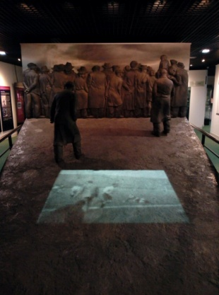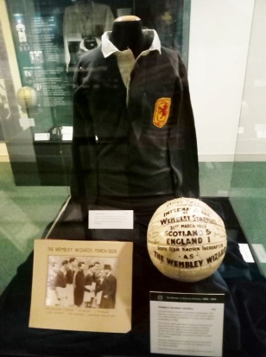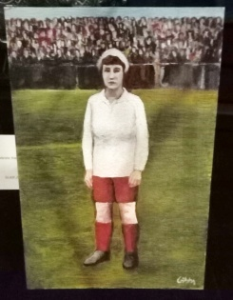

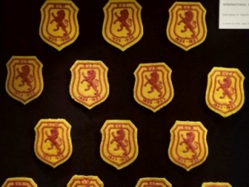

Activity Sheet on page 8 - Answers

From top to bottom: the 1928 Wembley Wizards ball, a Ghurkha knife, a Meissen vase, Art Deco Rangers teapot, Jimmy McGrory’s boots.

Quiz on pages 9 and 10 - Answers

1. 130 000

Because people were squashed/couldn’t breathe properly

The Duke of York

1. Factories, weapons, sports teams, munitionettes, Dick Kerr Ladies, FA, Scotland
2. It rained; the Scottish players were short and could move faster

The rose and thistle, which represent England and Scotland

He stuffed it under his jumper!

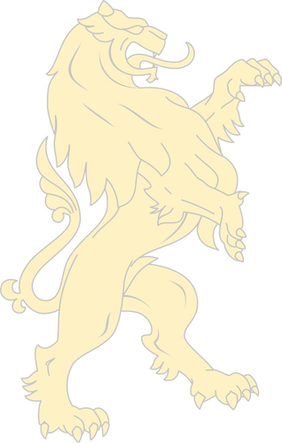The Hampden Roar Activity Sheet

1. Can you find...?

Look for the following objects, then write their name and draw them in the box next to each question.

Something that was stolen by a goalkeeper?

...................................................................

Something sharp that came from India?

...............................................................

Something with snakes on it?

... ....................................................

An object for pouring tea?

.......................................................

Something a blind boy made?

.............................................

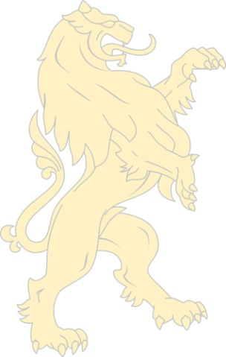The Hampden Roar Quiz

1. Crazy Crowds

Listen to the recording on the Hampden Slope.

How big was the crowd that day?

................................................................................

Why do you think ‘ambulance men work overtime on fainting case’s’?

......................................................................................................................................

Which member of the Royal Family greeted the teams?

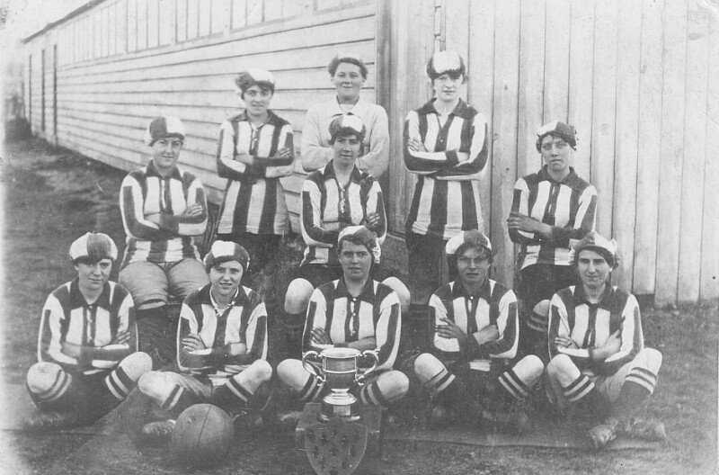......................................................................................................................................

1. Women in Wartime

Fill in the gaps in the following text.

During the First World War, when the men went away to fight, many women went to work in the ............................, making.................... and other important items. Women also had more opportunities while the men were away. Many factories founded.........................., as it was believed that this helped morale and made people better workers. The women who played in such teams were called ‘..........................’. Many people came to watch the women play, and teams such as ................................................. in Preston drew huge crowds. However, the football establishment was not happy about this, and in 1921 the English ..............decided to ban women from playing at their grounds. In 1924 ............................ followed their example, and women were banned until 1974. This made it a lot more difficult for women to play, but did not stop them trying!

factories Munitionettes sports teams FA weapons Scotland Dick Kerr Ladies



1. Wizards at Wembley

The Wembley Wizards got their name after a 5-1 victory against England at Wembley in 1928. Find the case about the match and answer the following questions:

Why did the Scottish team win? Give two reasons.

.........................................................................................................................................................................................................................................................................................................................................................................................................................

There are two flowers on the programme from that day. Which flowers are they, and what do they represent?

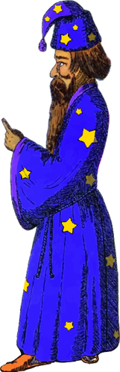...........................................................................................................................................................................................................................................................................................................................................................................................................................

How did Jack Harkness manage to keep the ball after the game?

...........................................................................................................................................................................................................................................................................................................................................................................................................................

**Changing Times, 1946-79**

Key Topics

After the end of WWII, football really took off in Scotland and the first teams started **playing in Europe**. The advent of stadium floodlights also allowed matches to be shown live on television for the first time in Scotland. In 1967, Celtic beat Inter Milan in Lisbon to win the European Cup. The team became known as The Lisbon Lions. Then in 1972 Rangers won the European Cup Winners’ Cup. This could be seen as a Golden Era for club football in Scotland.

However, Scotland were not as fortunate in **the World Cup** during this time, suffering heavy defeats in both 1954 and 1978, the latter of which is still a painful memory for those old enough to remember. One silver lining from the ’78 World Cup was Archie Gemmill’s goal against the Netherlands, still seen as one of the greatest World Cup goals of all time.

In this period, playing football with a rubber or **Tanner Ball** became popular. This was a cheap way for young children to play football even if they couldn’t afford a real ball. Games were often played in the street and it was an excellent way to develop precision ball skills.

In 1974, the **ban on women’s football in Scotland was finally lifted**. However, many players had already left the country in search of better opportunities abroad, including Rose Reilly who played in both France and Italy, and with Italy went on to win an unofficial forerunner to the Women’s World Cup in 1984.

*Key objects From left to right: Tanner Ball display; the 1967 ’Lisbon Lions’ programme; the 1972 first official women’s international programme; display relating to Archie Gemmill’s goal at the 1978 World Cup.*

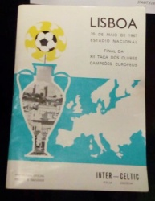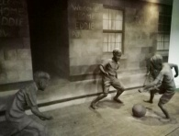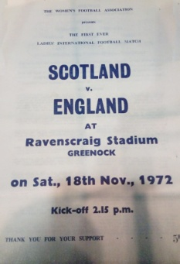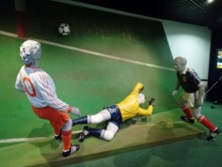

Activity Sheet on page 12 - Answers

1. 1: the penalty spot from Wembley, 2: a floodlight, 3: Jimmy Mason’s Scotland cap from 1949, 4: ‘rub studs’, 5: the Berwick Rangers Scottish Cup celebration menu from 1967.

Quiz on pages 13 and 14 - Answers

1. Bonus: The Liquorice Allsorts
2. a) Any of the following: bigger crowds (‘average gate of 6000’); better opportunities; the game was semi-professional; conditions in the UK at the time were difficult.

b) AC Milan

c) 1972

d) 1974

Bonus: girls can now play in school; more teams to play in; positive role models on TV etc.

1. Ally MacLeod was the manager, and Archie Gemmill scored the famous goal.

Changing Times Activity Sheet

1. We have so many objects here in the museum, and sometimes we can’t remember what they are! Can you help us work out what these mystery objects are? Find them in the display cases and write their names next to the pictures.

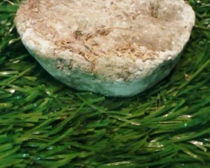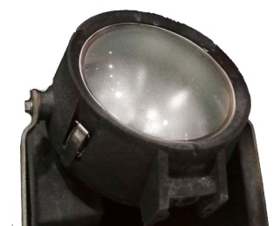

1..................................................

2.............................................

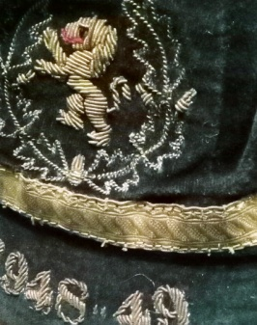

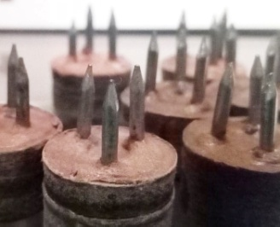

3..................................................

1. 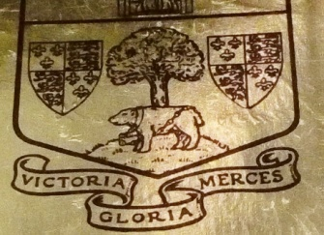

4..................................................

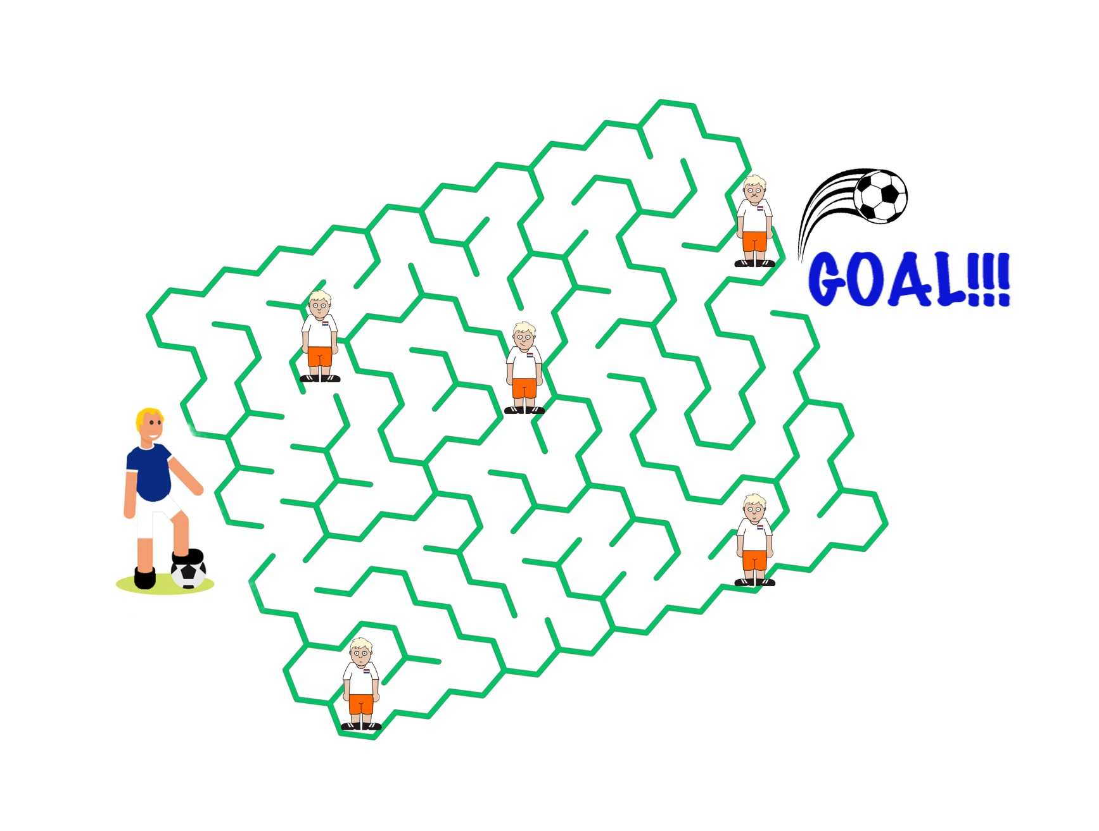

5..................................................

1. Can you help Archie Gemmill make his way through the Dutch opposition to score his amazing goal at the 1978 World Cup?

Changing Times Quiz

1. Fun Names

In 1967, Celtic won the European Cup, beating Inter Milan. As they played the final in Lisbon in Portugal, they were nicknamed the Lisbon Lions. Imagine that your team won an important game at the following places. What could you call them?

The Hampden.................................

The Wembley.................................. (tip: if you have done the Hampden Roar Quiz, that should give you an idea!)

The Glasgow...................................

The Paris.........................................

Bonus: In the World Cup in 1954, Scotland did not do very well, and they also got a nickname. This nickname came from the fact that their kits were all different colours! Can you guess what the nickname was? If you’re stuck, look in the case about the 1950 and 1954 World Cups for help!

............................................................................................................................................

1. Changes for Women

Look for the case about women’s football in the 1970s, and then answer these questions.

1. Why do you think many women couldn’t resist ‘the lure of Italian football’?

............................................................................................................................................

1. Who did Rose Reilly first play for in Italy?

............................................................................................................................................

1. When was the first official international women’s match?

............................................................................................................................................

1. When did Scotland allow women to play football at Association grounds?

...........................................................................................................................................

Bonus: Do you think it is easier now for women and girls to play football? Try to explain your answer in as much detail as possible, thinking of examples.

...........................................................................................................................................................................................................................................................................................................................................................................................................................................................................................................................................................................................................................................................................................................................................

1. World Cup Woes

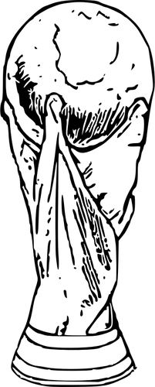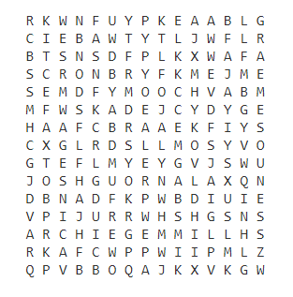Can you find the names of 6 members of the 1978 World Cup squad that went to Argentina?

Graeme Souness Archie Gemmill Ally Macleod Joe Jordan Kenny Dalglish Alan Rough

Which one was the manager?..................................................

Which one scored the famous goal against the Netherlands? ............................................

**A New Era, 1980- Present Day**

Key Topics

The 1980s was when football became big business, with the **rise of football stars** as we know them today. This was helped by the rise of high-profile competitions and an increase in media coverage of games and players. This was also the era in which fanzines became very popular, a trend which began after many fans complained about how boring the official club magazines had become.

The women’s team has gone from strength to strength in recent years, qualifying for both **EURO 2017** and the **2019 World Cup**. In both tournaments they narrowly missed out on a place in the elimination rounds. In this section you will also find objects relating to **EURO 2020**, with Glasgow being one of the 13 cities chosen to host this special tournament celebrating the European Championship’s 60th birthday. Brussels later withdrew and close to the tournament commencement Dublin and Bilbao were removed with Seville replacing Bilbao resulting in there being 11 host cities.

In the centre of the museum you will find the **SFA International** **Roll of Honour**, which recognises male and female players who have played 50 times or more for their country. Beyond this is the **Clubs Gallery**, which displays a jersey from each of the 42 senior clubs in Scotland. The clubs are organised by area, with a North and South gallery.

*Key objects*

*From left to right: the display of fanzines; Ally McCoist’s Golden Boot; the men’s and women’s Roll of Honour; the Clubs Gallery.*

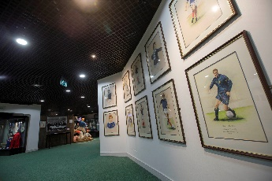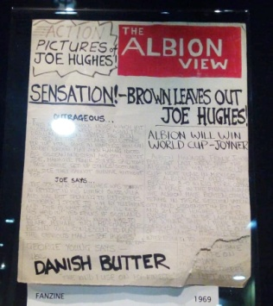

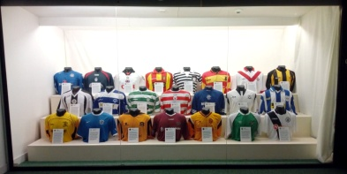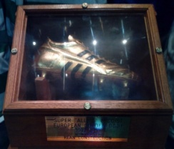

A New Era Activity Sheet on page 16 - Answers

Clockwise from top left: Airdrieonians, Motherwell, Aberdeen, Greenock Morton, Stirling Albion, East Fife

SFA International Roll of Honour Maths Challenge on page 17 - Answers

1. 179
2. 6
3. 9
4. 2
5. Willie Miller

A New Era: Activity Sheet

We have been cleaning the Clubs Gallery and have lost the labels for some of the shirts! Can you work out which clubs they belong to? Write the answers in the boxes.

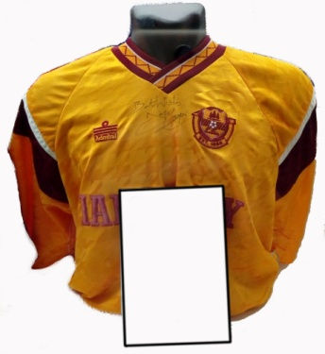

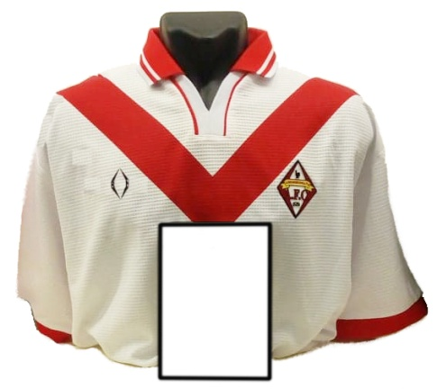

**?**

**?**

...................................................

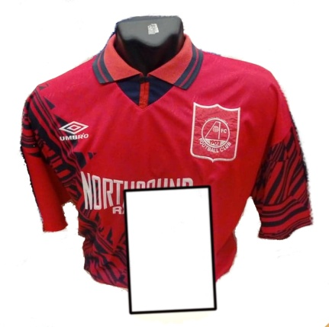

...................................................

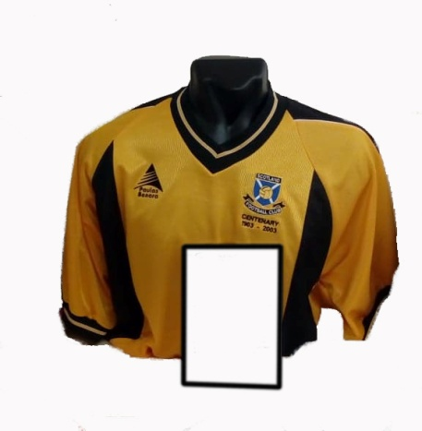

**?**

...................................................

**?**

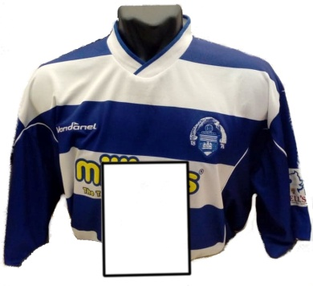

...................................................

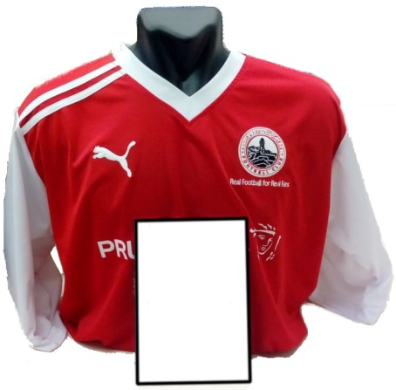

**?**

...................................................

**?**

...................................................

SFA International Roll of Honour Maths Challenge!



1. If you add together the number of caps won by Kenny Dalglish and Alex McLeish, how many do you get?

.................................................

1. If you take Maurice Malpas’ caps away from Ally McCoist, how many would Ally have left?

..................................................

1. If a player has 41 caps, how many more do they need before they can enter the Roll of Honour?

....................................................

1. If you add together Kim Little and Julie Fleeting’s caps, and then divide that number by Joanne Love’s caps, how many do you get?

.....................................................

1. I have more caps than Richard Gough, but not as many as David Weir. If you divide the number of caps I have by 5, you get 13. Who am I?

.......................................................



**The Scottish Football Hall of Fame**

Key Topics

The Scottish Football **Hall of Fame** was established in 2004 to honour people who have made a great impact on Scottish football. Unlike the Roll of Honour, the people nominated do not have to have earned a certain number of caps for Scotland. In fact, they don’t need to have played for Scotland, or even played football at all! In addition to player’s, the Hall of Fame honours many categories of people who have made a significant impact in Scottish football, including managers, journalists, and medical staff. In order to be inducted, a person needs to be nominated, either online or in writing, and then chosen, from a short list, by a panel of judges. They are then officially inducted into the Hall of Fame at an annual awards ceremony at Hampden Park. Anyone may be nominated for the Hall of Fame, and visitors to the museum can do so by filling in a Nomination Card and posting it into the box in the Hall of Fame space. There is one important rule however: a player may only be inducted only once they have retired from their playing career.

*Key objects*

*From left to right: Hall of Fame space and video display; nominations cards and box.*

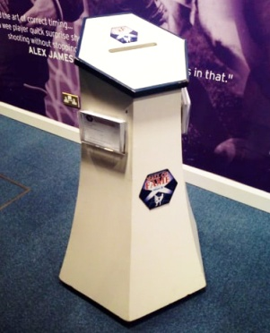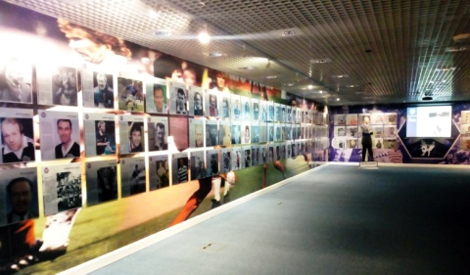

Hall of Fame Bingo on page 19 - Answers

There are several possible answers for each of the boxes, except the following:

Nicknamed ‘Jinky’: Jimmy Johnstone

Played for two teams at once: Rose Reilly

Scored 116 goals for Scotland: Julie Fleeting

Hall of Fame Bingo!

Work in pairs to find an inductee who fits each description below. For some there will be many people, and for others there is only one. Once you have found them all, shout ‘Bingo!’ The first pair to do so is the winner. Note: you can’t use the same name twice!

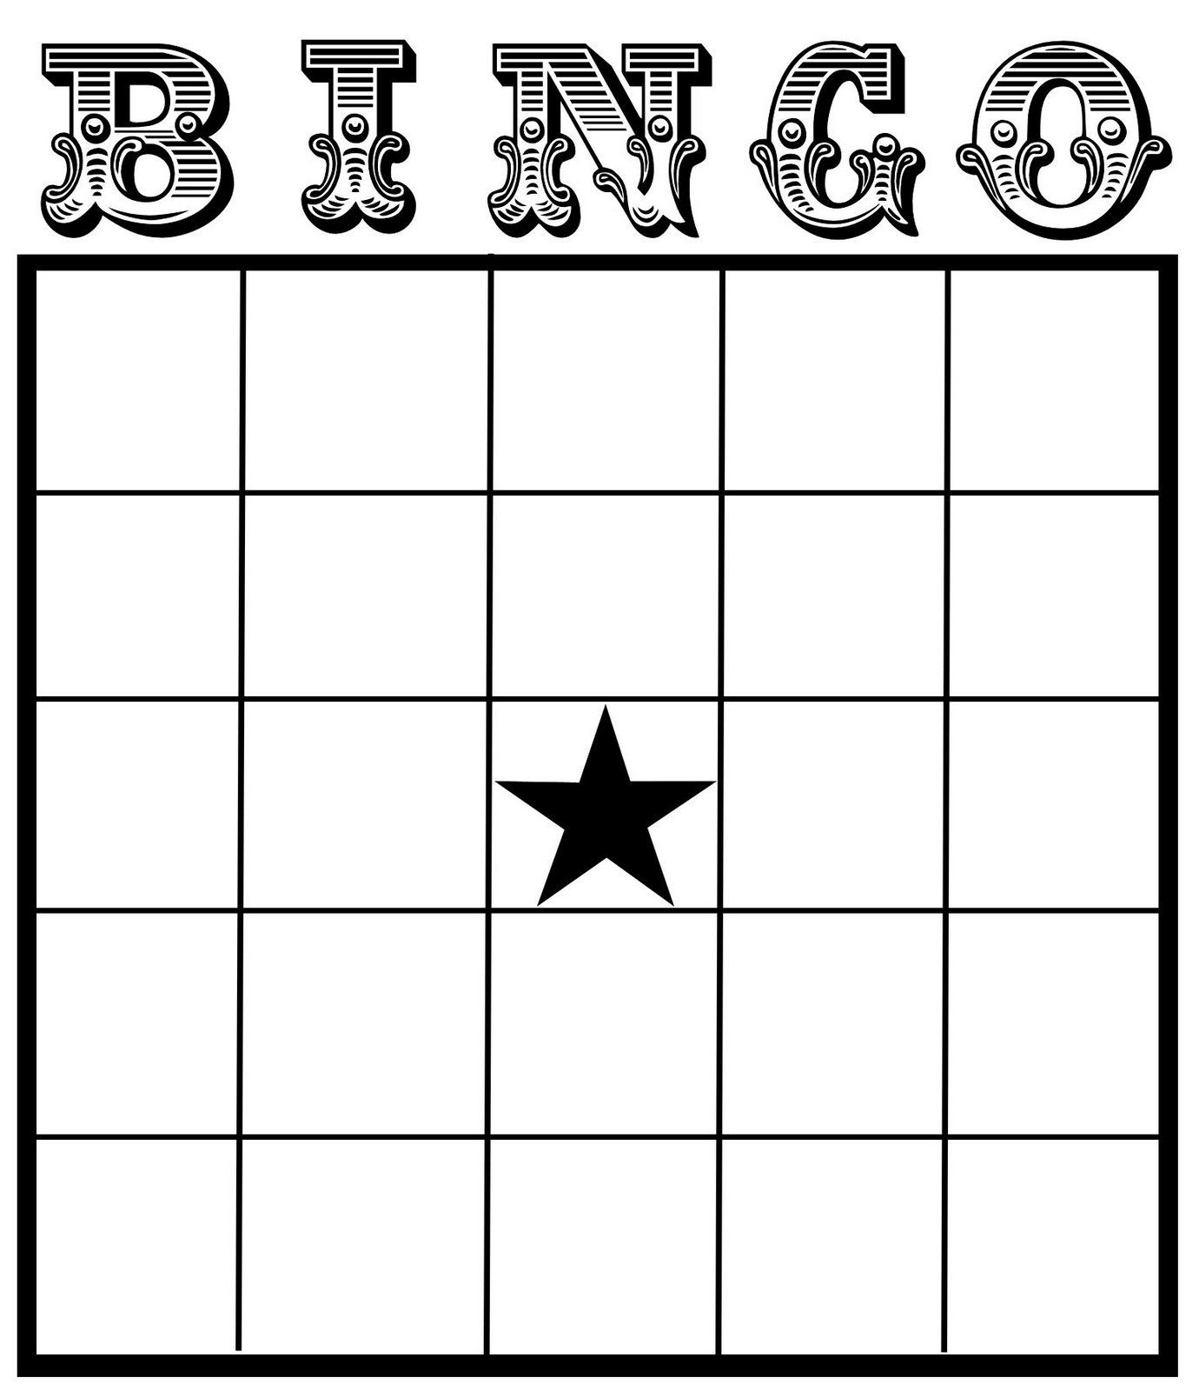



Was nicknamed ‘Jinky’

........................

Played for two teams at once

..............................



Played for more than 3 Scottish teams

.........................

Managed a Scottish team

.......................

Scored 116 goals for Scotland?

...........................



Was a goalkeeper

........................

Didn’t play

football

..............................



Was born more than 100 years ago

........................

Is smiling in their

photo

..............................

Played for both

Celtic and

Rangers

..........................





Was a writer

........................

Won the Scottish Cup with their team

...........................

Bonus activity: Think of someone you would like to nominate. Who would it be and why? If you don’t know much about football, perhaps you can choose someone you have read about in the museum today.

.........................................................................................................................................................................................................................................................................................................................................................................................................................................................................................................................................................................................................................................................................................................................................................................................................................................................................................................................................................................................................................................

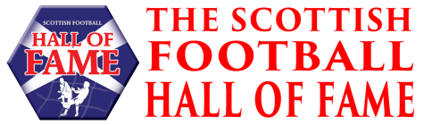

This booklet was compiled by Katherine Midgley, December 2019. Not for commercial use.